Why do we need to write super(props) in case of Class Based Component ?

Order in which component is called:

Parent: constructor > render > Class Based Component > Parent ComponentDidMount  
Child: constructor > render > ComponentDidMount

ComponentDidMount is called once the component is completely mounted.

Once the child component is mounted successfully in parent-child relationship, only after that parent component ComponentDidMount will be called.  
  
Why ComponentDidMount is used ?  
 - make api calls.  
  
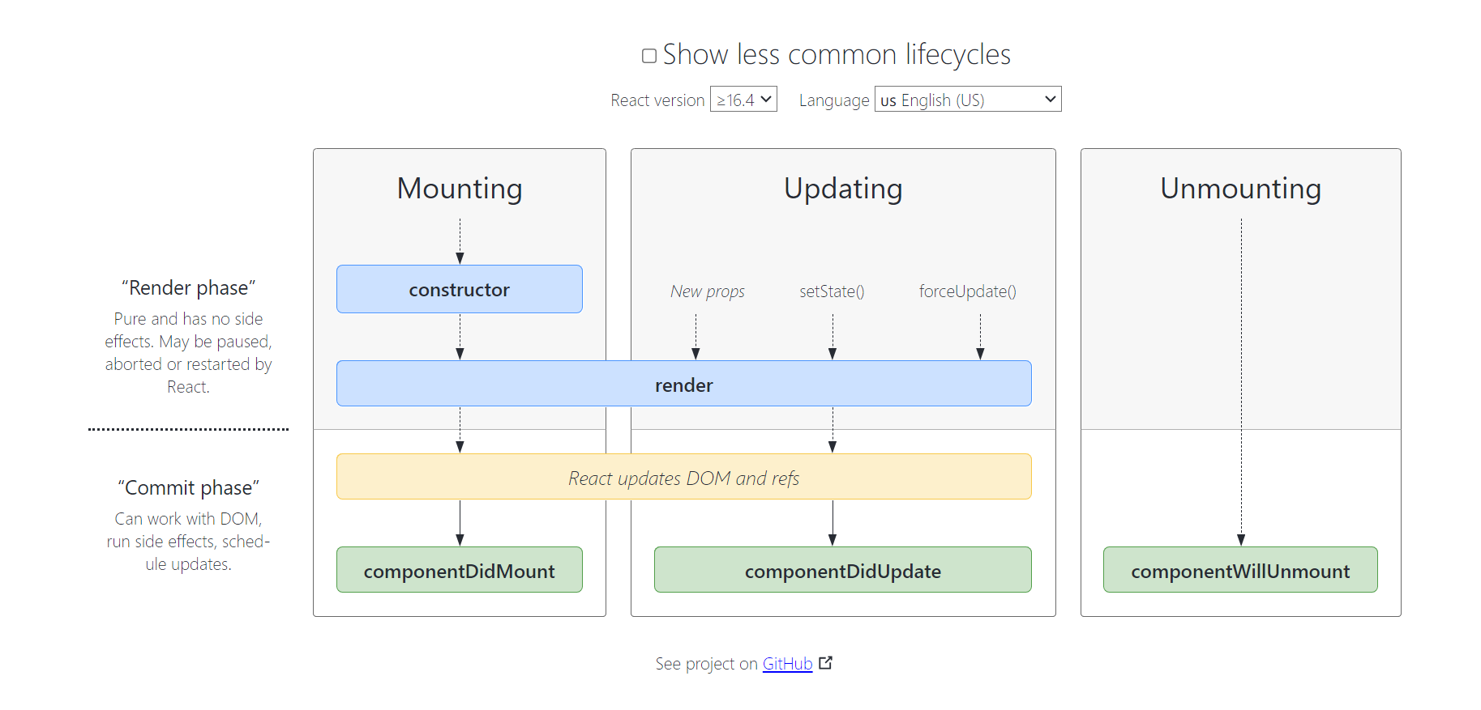  
  
Reason why React is fast because it works in 2 phases:  
a. Render Phase  
b. Commit Phase  
  
Once the DOM is rendered than ComponentDidMount is called. Hence, this is the reason we make api calls in componnetDidMount.